Global Partnership on Output Base Aid Project
Sub – Project Environmental Assessment Report – NO 03
Waste Water Collection & Disposal System for Badovita Area

GPOBA Project
National Water Supply and Drainage Board
Sri Lanka

1.0 Project Description
Badovita Housing schemes are located in Dehiwala/Mt. Lavinia Municipal Council area. This project area is comes under Ratmalana Divisional secretariat and katukurunduwatta GN Division. There are 5 housing schemes include to the project named as Stage 1 - Stage 5. These housing schemes located approximately 3km away from Galle Road. Nearly 1400 families are ling in Badoviita area and population is around 7000.
These people are severely suffering from lack of sanitation facilities as they are not having proper waste water disposal system. Existing septic tanks are frequently overflowing. Most of toilets are overflowing frequently.
Most of people are living in 2-3 perch area and majority of them are poor.
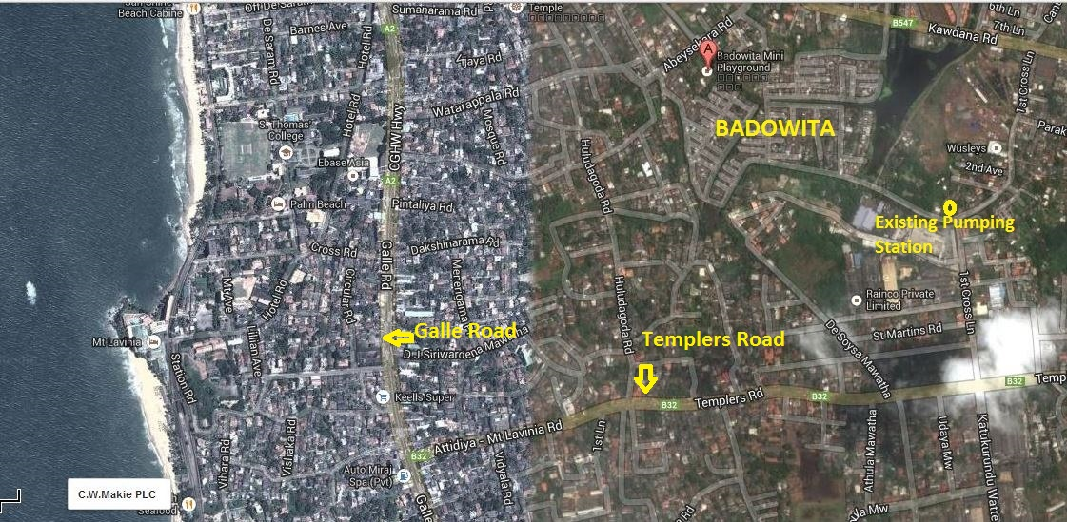

1.1 Proposed system
All toilets are connected to proposed gravity sewer and collected wastewater will be connected to propose pumping stations as shown in Figure 1.1. Collected W/W from catchment 1 will be comnnected to PS 1 and Catchment 2 collected W/W will be directed to PS2. Pumped flow from PS1 and PS2 will dischege to proposed cllection manholes of catchment 03. All W/W from catchment 01,02,03 will be directed to PS3. Main proposed pumping station(PS3) will be directed to Existing Pumping station constructed under Moratuwa/Ratmalana wastewater project which is directed to soysapura wastewater treatment plant.
All pumping stations will be automated by SCADA systems and will be operated and monitored by soysapura treatment plant office.
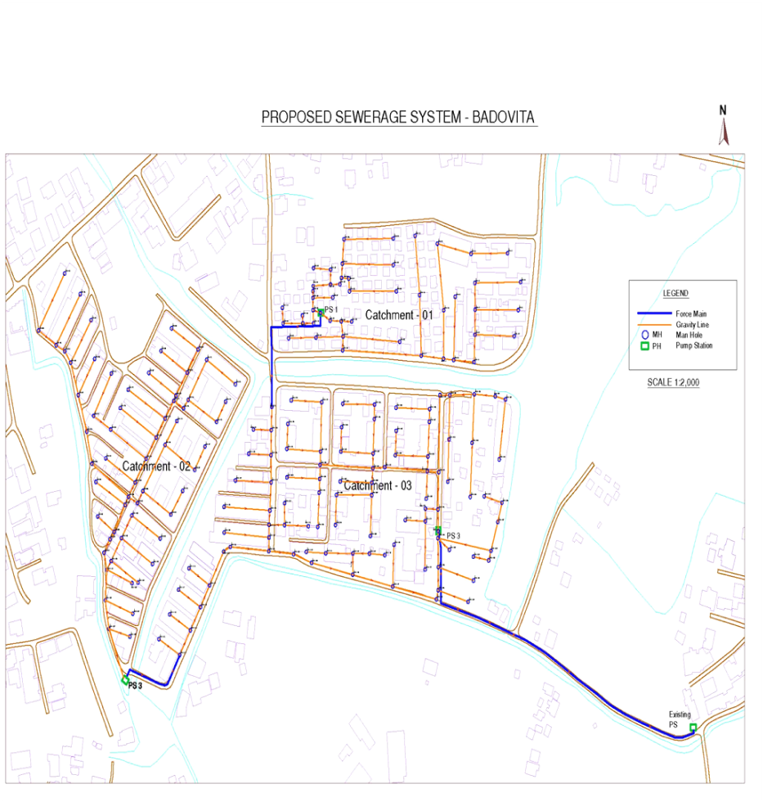
Figure 1.1 Key Plan, Proposed Wastewater collection and Diposal system for Badovita
2.0 Required approvals and permits
- Environmental clearance from the Central Environmental Authority (CEA).
- Construction Approval from Dehiwala Municipal Council
- Land Clearance from Dehiwala Municipal Council
- Road breaking and reinstatement approval from Dehiwala Municipal council

All approvals which have taken are attached in the annexure 1-3
3.0 Existing Environmental Condition in project area
3.1 Geology
The general topography of the Badovita area consists of largely flat low lying terrain. Elevations vary only from 6m MSL to 8m MSL.

3.2 Stratigraphy and sub soil condition
Top most top layer of utilized area is consisting of gravel fill (1m-2m) and rest is covered by peaty soil and covered by water. Thick peat layer can be found below the gravel fill. There are thin silt layers and clay layers can be seen up to 8m depth and bed rock can be found 8m – 12m depth.
3.3 Rainfall characteristics and monthly average rainfall
Rainfall in the area is peaks in May to October. The general rainfall is monsoonal, conventional and digressional origin. The average annual rainfall for the project area is around 2000 – 3000 mm. Daily rainfall is measured at the principal meteorological station Ratmalana maintained by the Department of Meteorology.
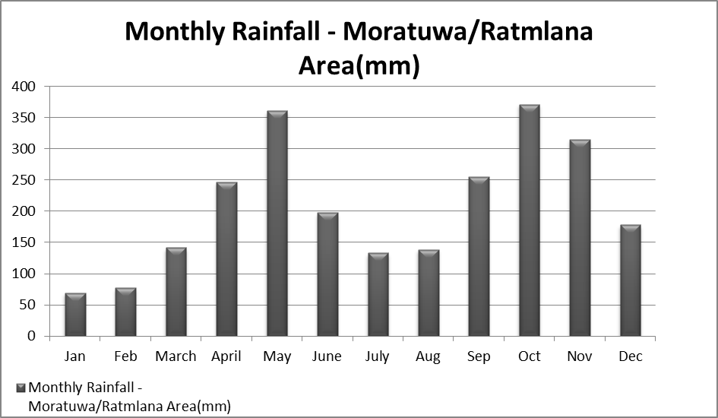

As the ground water table is close to the ground level surface runoff is high.
Monthly Runoff for Moratuwa/ Ratmalana area is as follows.
Month | Jan | Feb | March | April | May | June | July | Aug | Sep | Oct | Nov | Dec
Runoff (mm) | 49 | 54 | 99 | 173 | 252 | 139 | 93 | 98 | 178 | 260 | 220 | 124

3.4 Wind Speed and Direction
Average wind speed is in the range of 7-10km/hr according to the data recorded at the Colombo meteorological station.
Month | Wind Speed (km/hr) | Dominant Direction
January | 9 | North East
April | 7 | South West
July | 10 | South West
October | 8 | South West

3.5 Temperature
Average annual temperature is in the area is in the range of 25-27.5 ⁰C
3.6 Relative Humidity
Relative humidity data are available for Ratmalana meteorological station, which is in the project area. Relative humidity is from 66% to 75% during the daytime, and it varies from 84% to 90% during the nighttime.
3.7 Hydrology
Surface drain pattern
Open drains and badovita canals are helping to have surface drain and it is largely determined by Attidiya Lake. But in rainy seasons this area people are suffer from flood.
Surface water availability & uses
Badovita area surrounded by water logged areas or canals in every direction. It is hard to use available water due to higher pollution of water by domestic waste and industrial waste.
Height of Ground water table
Water table is high in the Badovita area as it is surrounded by water logged and marshy areas. Ground water is contaminated by domestic wastewater and industrial wastewater.

Groundwater Uses
The quality of Groundwater is degraded in the area because of the domestic and industrial wastewater contaminated with the groundwater.
Marine Outfalls
This area is located nearly 5 km away from the sea
3.8 Water quality
NWSDB have established a water quality monitoring programme with sampling point located closer to the site (Annex) . Samples will be taken quarterly basis.
Water quality testing for the first quarter of the year 2013 was done and results as follows.
Sampling location at Badoviita
 | Parameter | Value
1 | BOD₅ | 480 mg/l
2 | DO | Nil
3 | E-coli⁵ | 18 x 10⁵
4 | Total fecal coliforms | 18 x 10⁵

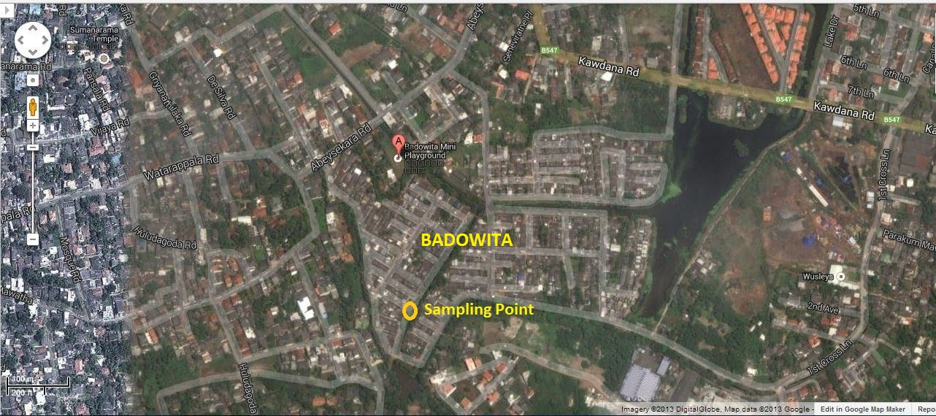
Figiure 3.1 Sampling Location at Badovita

4.0 Possible Environmental Impacts
- Dust can be generated during the construction period.
- Possibility of odor from the pumping stations Pumping station

EMMP including preventing, Monitoring, Mitigation measures and identification of responsible parties
 | Key Impacts | Mitigation Measures | Monitoring actions | Responsible parties
1 | Dust generation during the construction period | Dust control measures such as spaying water in the dry seasons during construction period | Monitoring during site inspection and feedback from the community around the area | NWSDB and Contractor
2 | Possibility of odor from Pumping stations | Avoidance of overflow by proper operation and monitoring. Inlet to the wet well comes through screen and it will reduce odor generate by disturbing wet well W/W. |  | NWSDB

5.0 Modes of Public Consultation and Disclosure
Public consultation and awareness programmes were conducted with the participation of Honorable religious leaders and community leaders. There were no any objections from the community in the Badovita area and they wanted to hurry up the implementation of the project as early as possible.
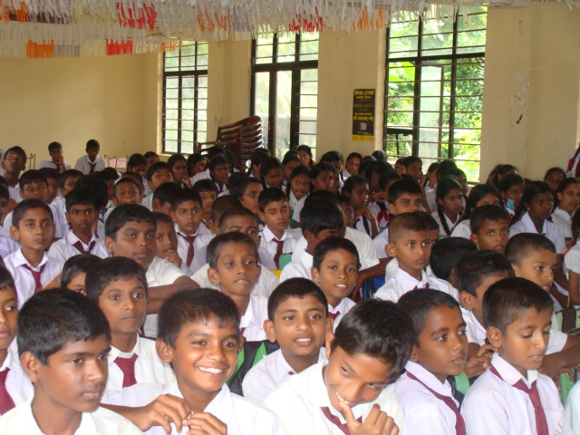
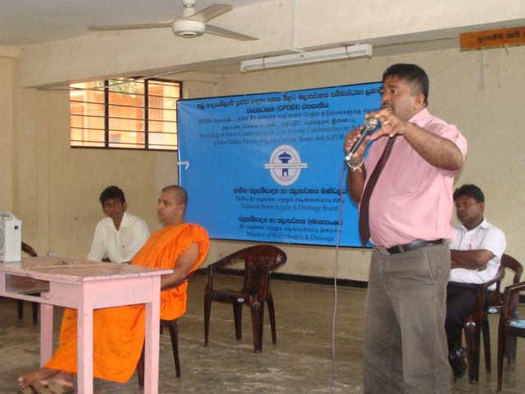
Figure. Awareness Programs for School Children in Badovita
