Global Partnership on Output Base Aid Project
Sub – Project Environmental Assessment Report – NO 06
Waste Water Collection, Decentralized Treatment and Disposal System for Lunawa Samudra Shakthi Housing Scheme

GPOBA Project
National Water Supply and Drainage Board
Sri Lanka
1.0 Project Description
The Lunawa Samudra Shakthi housing scheme is situated 150m from 20 km post along the Puranappu Raja Mawatha in the Moratuwa divisional secretary area of the southern part of the Colombo city. It is about 20m away from road center. This is a low income housing settlement and it is controlled under Condominium Authority. There are 20 flats and each flat consist of 8 housing units. The total of 160 housing units are occupying by approximately 800 people. This is located 60m away from the sea in a low lying flat surface area with a high water table of approximately 1 meter.
These people are severely suffering from lack of sanitation facilities as they are not having proper waste water disposal system. Existing septic tanks and soakage pits are frequently overflowing. Wastewater has logged in backyard of some flats and mosquitoes are breading in those places.
DEWAT system was proposed for this scheme as it is approximately more than 1.5 kilometers away from the existing sewerage network.
1.1 Proposed system
All toilets are connected to augmented Existing septic tanks existing connecting system will be rehabilitated. Anaerobic baffled reactors and anaerobic filters will be constructed adjacent to relevant septic tanks and septic tank effluent line will be connected to anaerobic Baffled reactors while ABR effluent line will be connected to proposed manholes through anaerobic filter. Gravity collection network will be constructed along road and finally it is to be connected to proposed pumping station. 110mm dia. Pumping main proposed to be cross the Puranappu Raja Mawatha , railway lines and connected to sea through 6m long outfall which is submerged end point by 1.5m in sea water.

2.0 Required approvals and permits
- Environmental clearance from the Central Environmental Authority (CEA).
- Construction permit from Department of Coast Conservation
- Construction Approval from Moratuwa Municipal Council
- Construction approval from Divisional Secretariat Moratuwa
- Approval from Marine Environment Protection Authority
Documents related to approval procedures are attached in Annexures (Annex 1- Annex…..)
3.0 Existing Environmental Condition in project area
3.1 Geology
The general topography of the Lunawa area consists of largely flat low lying terrain. Elevations vary only from 0m MSL to 1m MSL.
3.2 Stratigraphy and sub soil condition
Top most top layer is consisting of loose sand layer and there is a dense sand layer 3m below from the ground level. Due to the sandy sub soil layers permeability of sub soil is higher.
3.3 Rainfall characteristics and monthly average rainfall
Rainfall in the area is peaks in May to October. The general rainfall is monsoonal, conventional and digressional origin. The average annual rainfall for the project area is around 2000 – 3000 mm. Daily rainfall is measured at the principal meteorological station Ratmalana maintained by the Department of Meteorology.

As the ground water table is close to the ground level surface runoff is high.
Monthly Runoff for Moratuwa/ Ratmalana area is as follows.
Month | Jan | Feb | March | April | May | June | July | Aug | Sep | Oct | Nov | Dec
Runoff (mm) | 49 | 54 | 99 | 173 | 252 | 139 | 93 | 98 | 178 | 260 | 220 | 124

3.4 Wind Speed and Direction
Average wind speed is in the range of 7-10km/hr according to the data recorded at the Colombo meteorological station.
Month | Wind Speed (km/hr) | Dominant Direction
January | 9 | North East
April | 7 | South West
July | 10 | South West
October | 8 | South West

3.5 Temperature
Average annual temperature is in the area is in the range of 25-27.5 ⁰C
3.6 Relative Humidity
Relative humidity data are available for Ratmalana meteorological station, which is in the project area. Relative humidity is from 66% to 75% during the daytime, and it varies from 84% to 90% during the nighttime.
3.7 Hydrology
Surface drain pattern
There is no better surface drain for the Lunawa housing scheme as it is low lying area. Internal drain system of housing scheme is not functioning well due to damages of existing drain and non-availability of final discharge point connected to sea closer to the housing scheme. Lunawa area surface drain is largely determined by the sea.
Surface water availability & uses
Close to the site there some large drains which are draining surface runoff and domestic wastewater (Grey water) to the sea. There is a canal which carries surface runoff and wastewater close to the proposed site 800m away from south bound. It is highly polluted. There is no surface water source close to the site, which stores portable water.
Height of Ground water table
Water table is high in the Lunawa area as it is close to the sea and low lying area. Ground water is contaminated by domestic wastewater due to partial treatment of domestic waste water in septic tanks and untreated wastewater by overflowed septic tanks and toilets.
Groundwater Uses
The quality of Groundwater is degraded in the area because of the domestic wastewater contaminated with the groundwater. Further to that groundwater is salty as the site is located very close to the sea. Hence there is hardly any use of groundwater in the project area.
Marine Outfalls
The shoreline within the proposed project area is a rubble line which is constructed as barrier for tidal wave to avoid sea-erosion. Unauthorized human settlements can be seen along the coast and domestic sewerage and other waste have ruined the scenic value of the beach. Visual pollutants are scattered in the beach, on the rubbles and in the surface water of the near shore area. 800m away from housing scheme there is a drain outlet through a culvert to sea for storm water discharge in this area.

3.8 Water quality
NWSDB have proposed to established a water quality monitoring programme with sampling point located closer to the site and after construction of DEWATS plan to take samples from wet well of discharge pumping station (Annex Location of sampling) Samples will be taken quarterly basis.
Possible Environmental Impacts
- Sound can be generated from operation of submersible pumps
- Dust can be generated during the construction period.
- Possibility of odor from the anaerobic filters, Anaerobic baffle reactors, discharge point and Pumping station
- Water quality of sea nearby discharge point

EMMP including preventing, Monitoring, Mitigation measures and identification of responsible parties
 | Key Impacts | Mitigation Measures | Monitoring actions | Responsible parties
1 | Sound generated from pumps | Close the pump well by cover slab and checkered plates and use submersible pumps. |  | NWSDB/ CMA
2 | Dust generation during the construction period | Dust control measures such as spaying water in the dry seasons during construction period | Monitoring during site inspection and feedback from the community around the area | NWSDB and Contractor
3 | Possibility of odor from filters, Pumping stations and discharge points | Ventilation system for ABR,AF and PS, Discharge point submerged in sea water | Monitoring system to be arranged through CBO at housing scheme for sea outfall. | NWSDB
4 | Water quality of sea nearby discharge point | DEWATS have designed for marine water effluent discharge standards | water quality of DEWATS to be monitored quarterly | NWSDB/CMA

*CMA- condominium Management Authority
*CBO- Community Based Organization

Modes of Public Consultation and Disclosure
Public consultation and awareness programmes were conducted with the participation of Honorable Mayer and Municipal council members and GS. There were no any objections from the community in the Lunawa housing scheme.

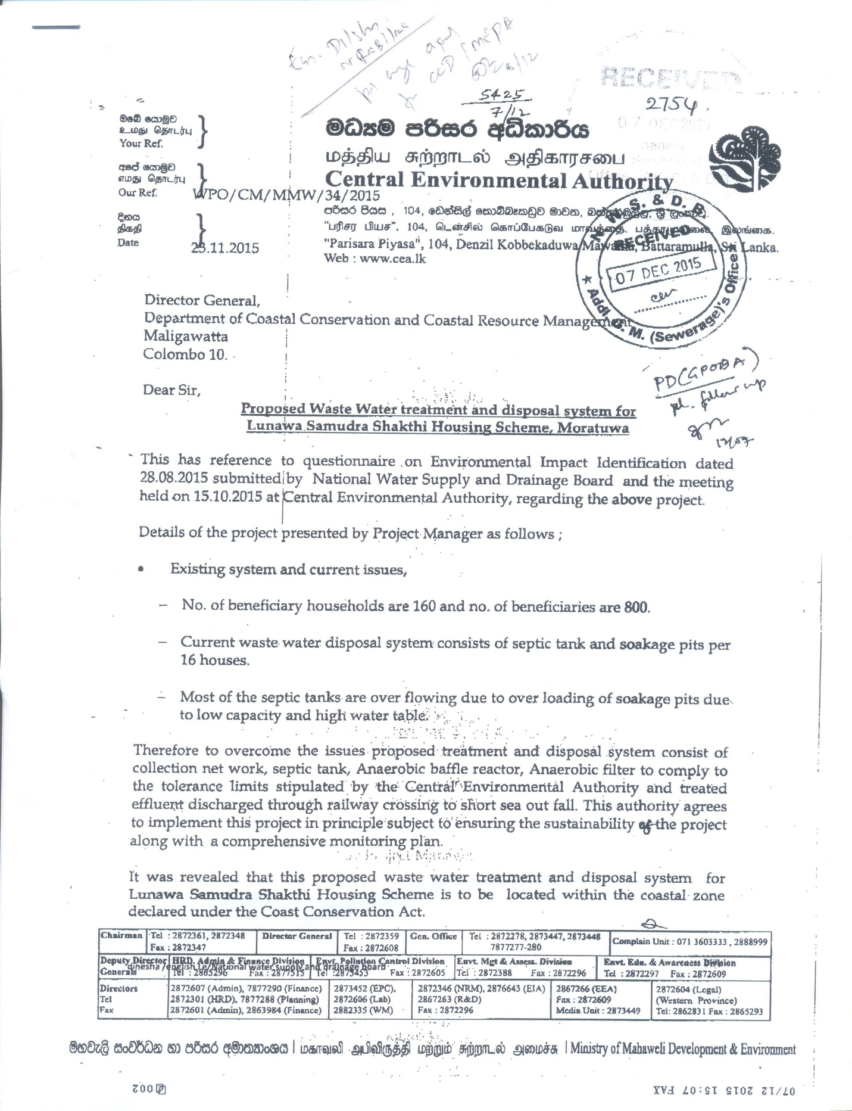
Annex 1
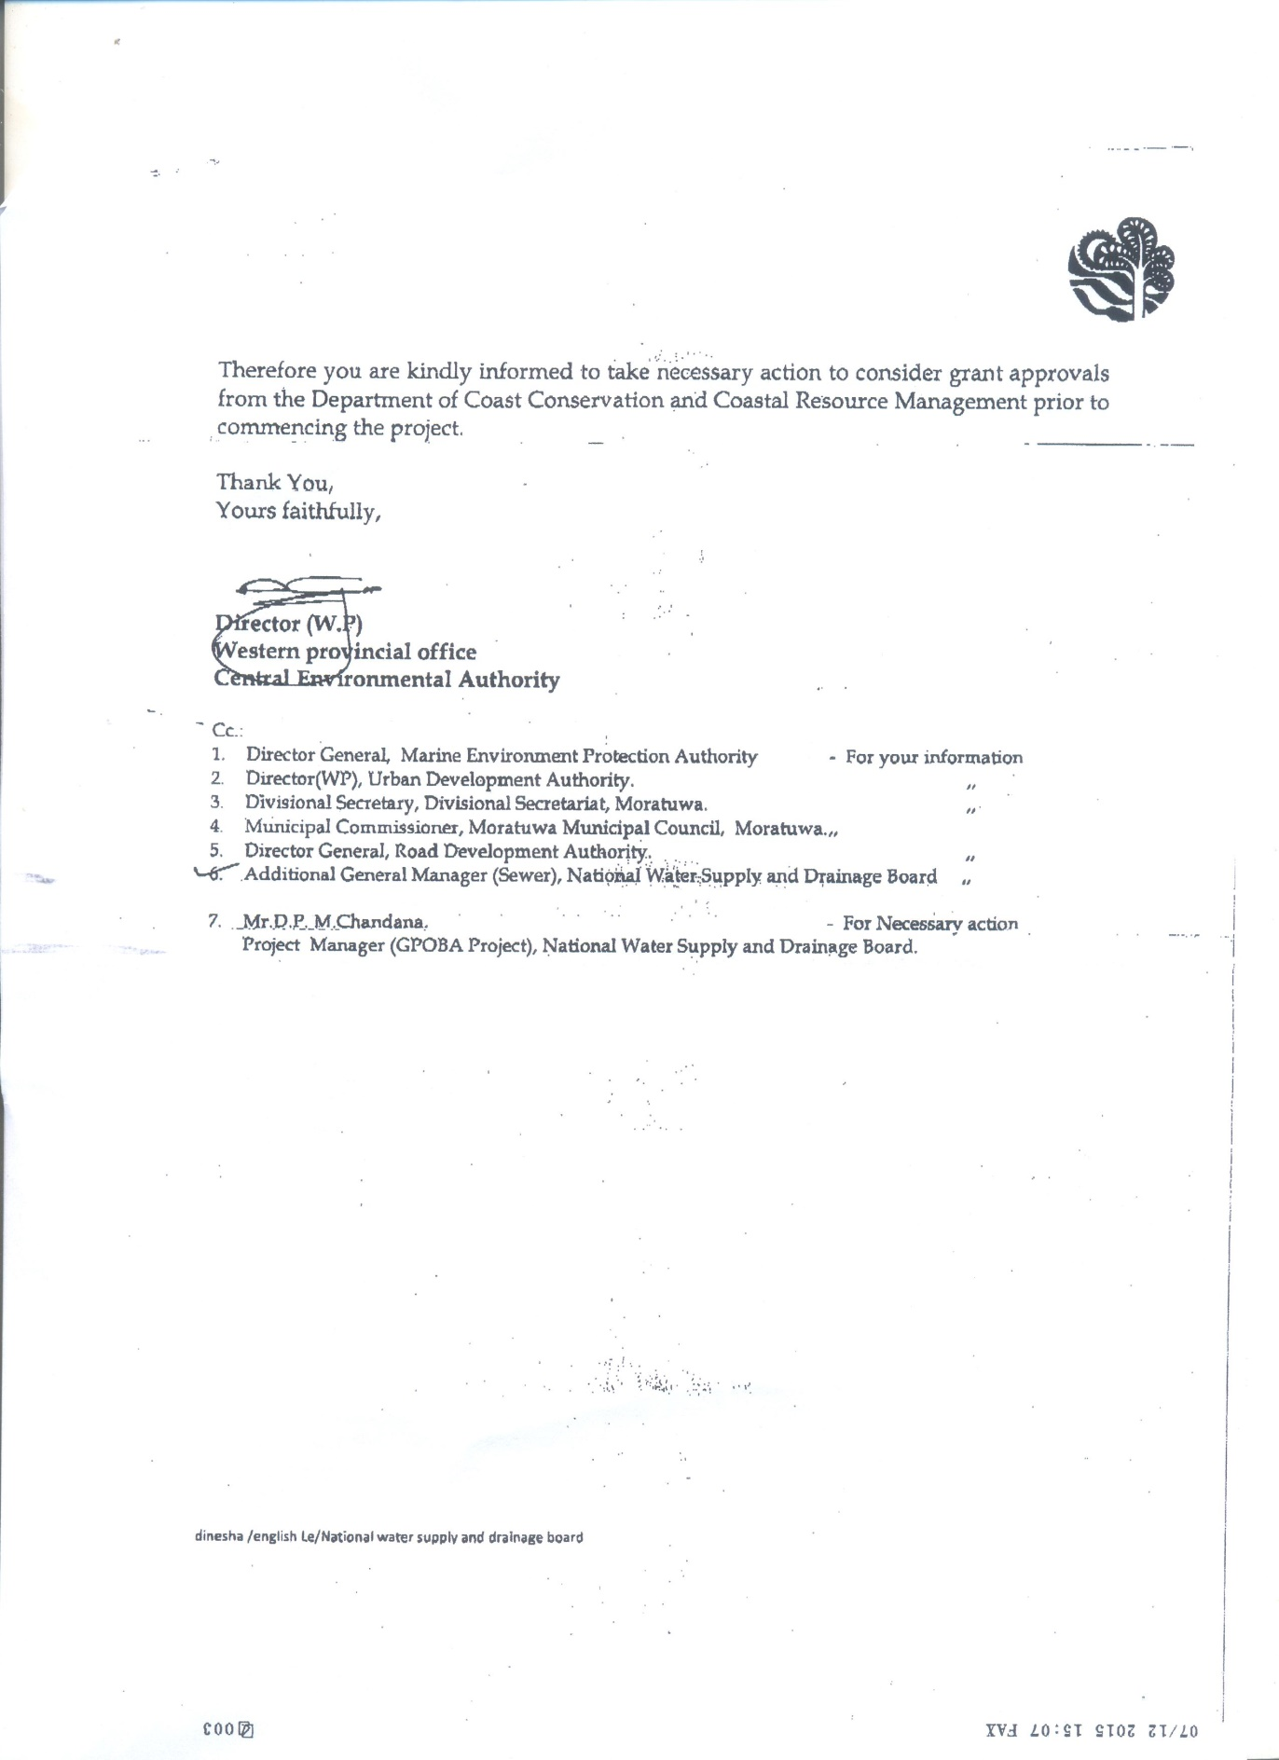
Annex 2
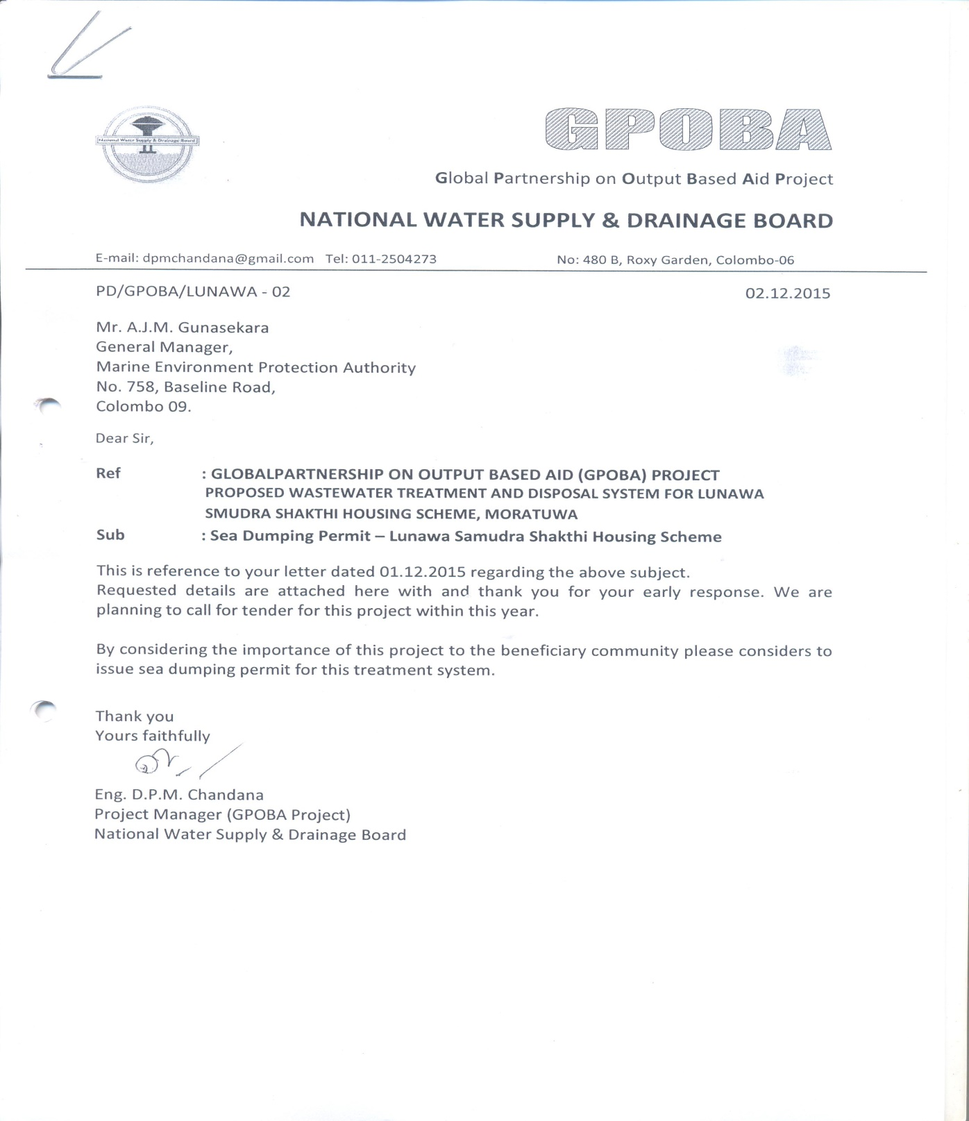

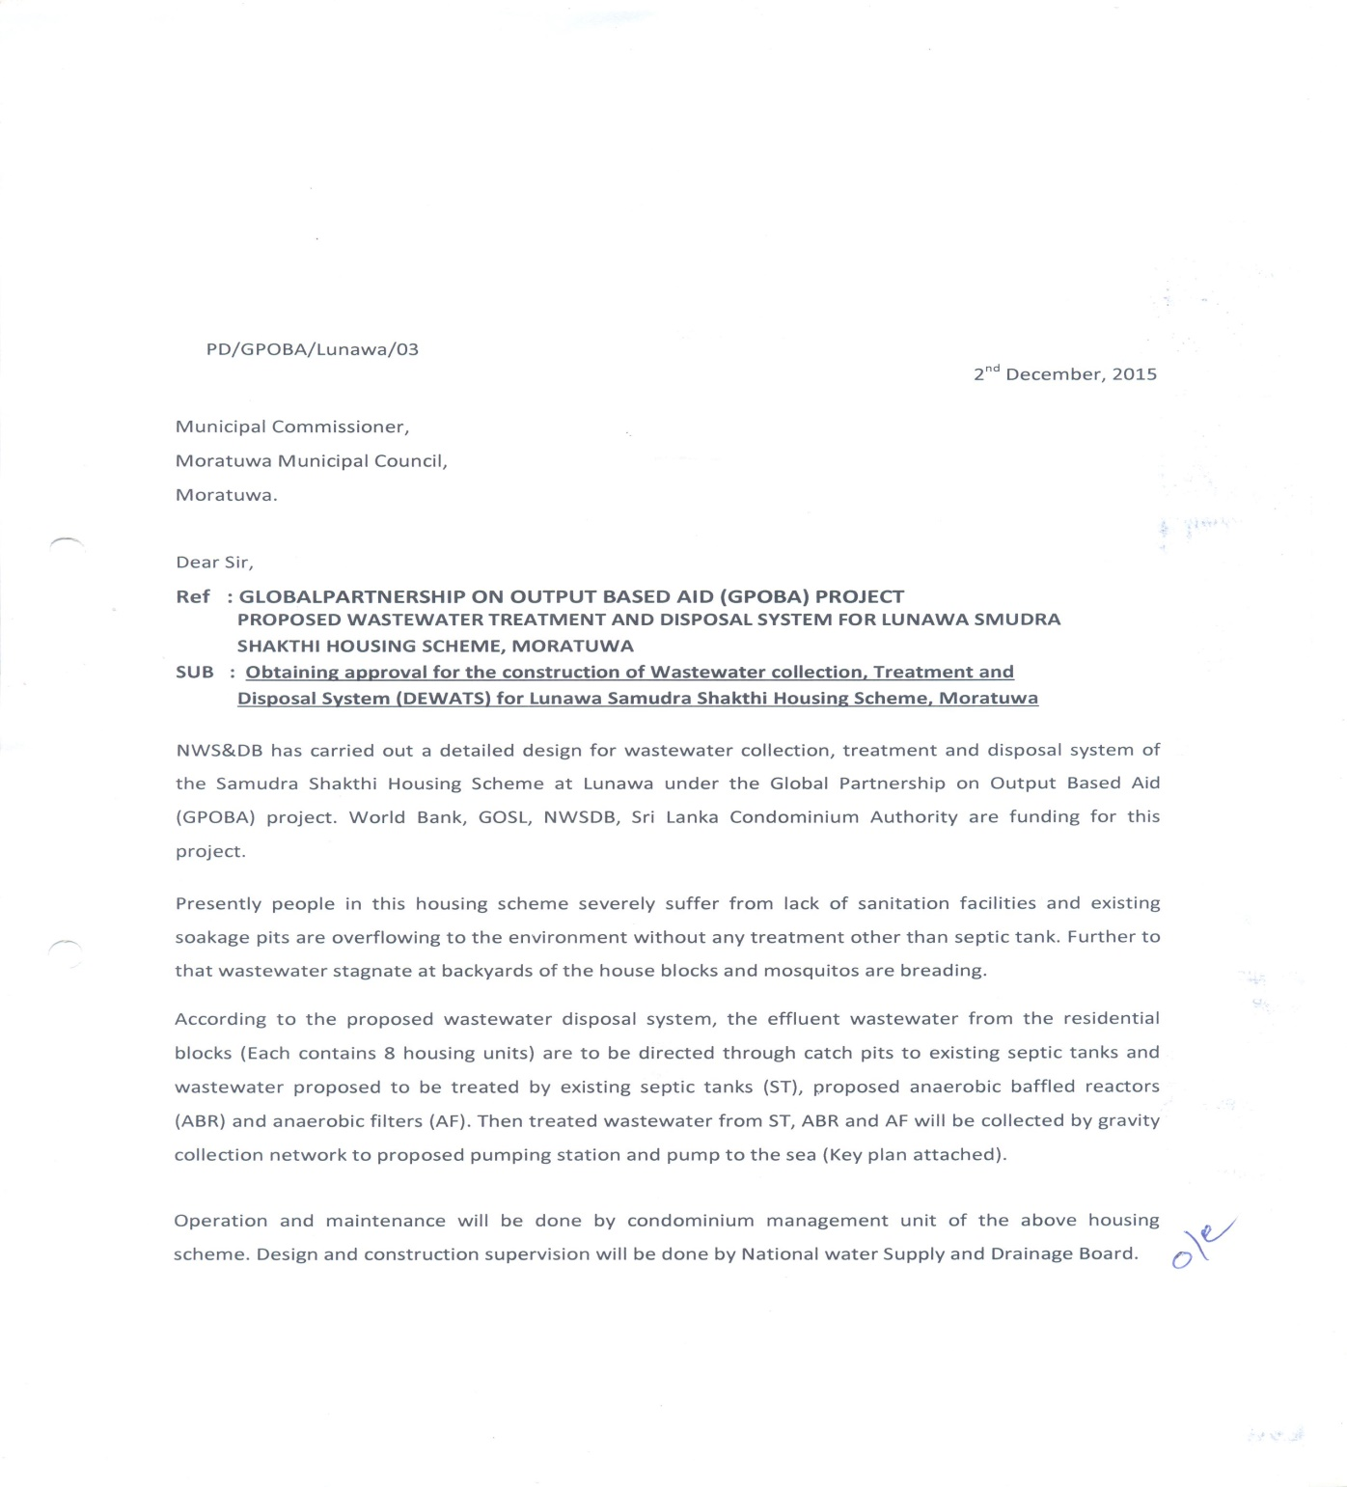
Annex -3

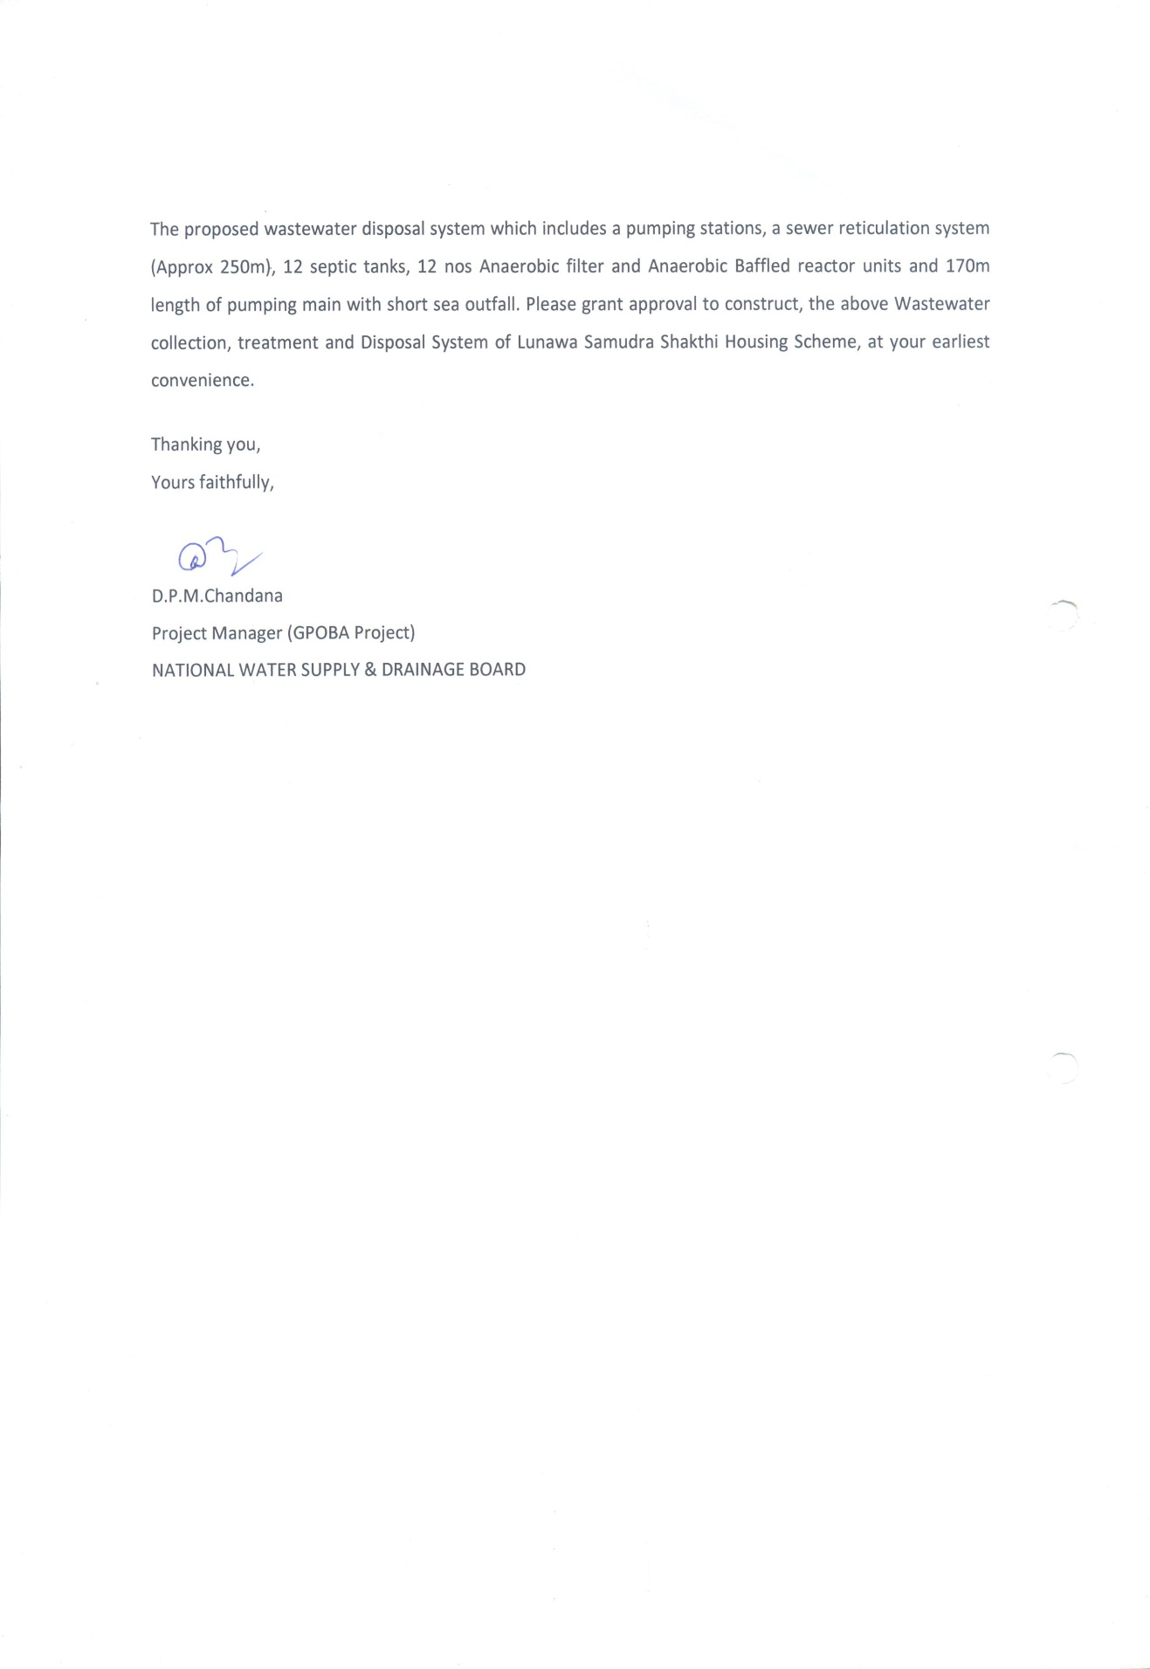
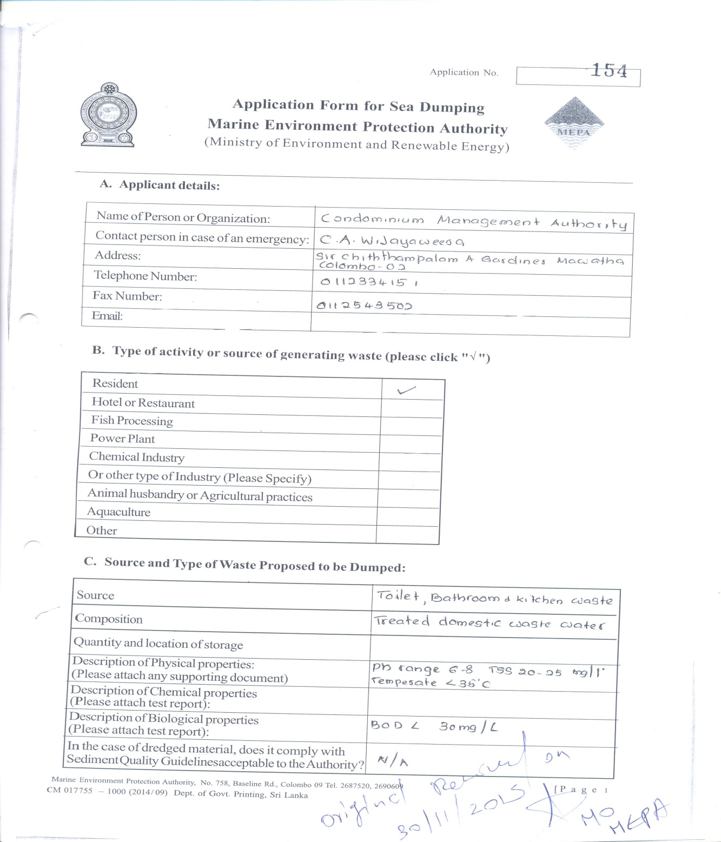
Annex-4

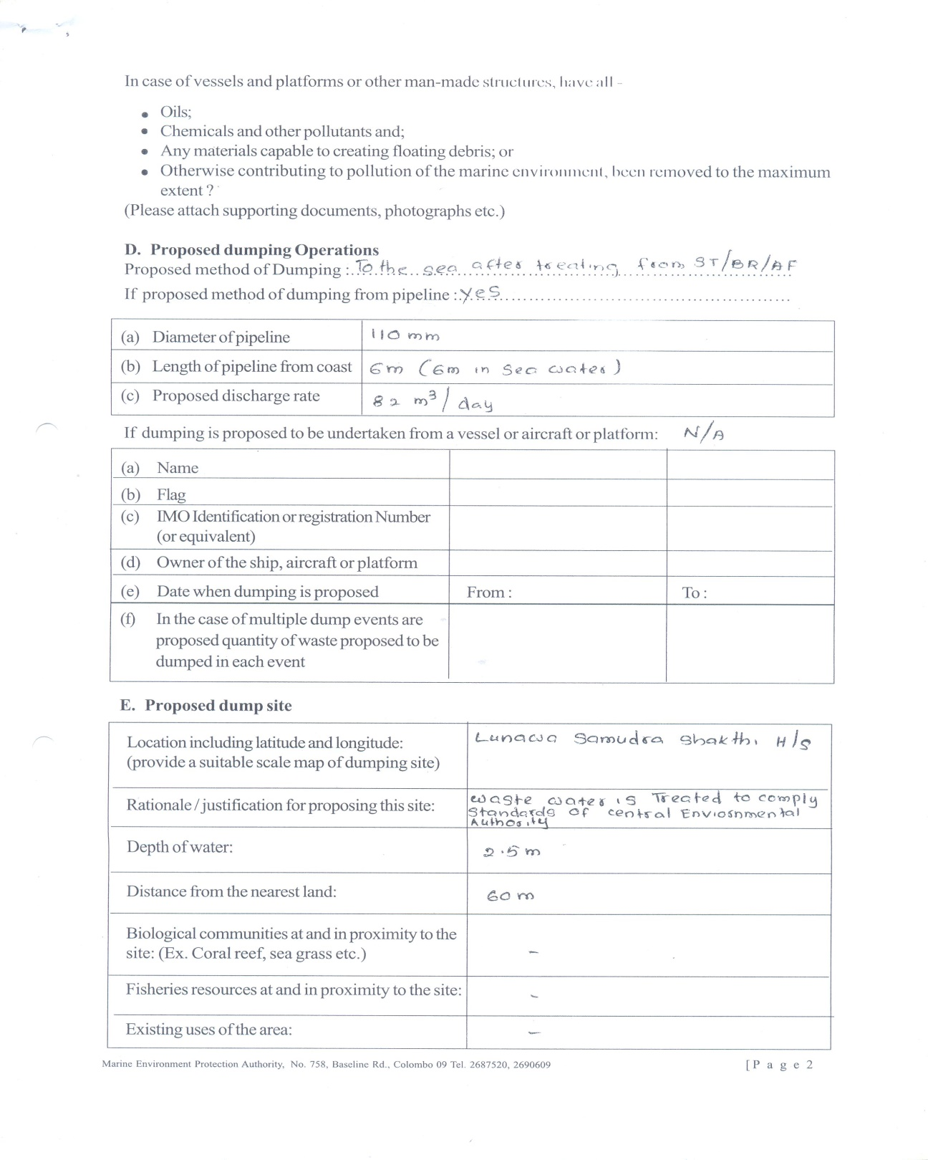

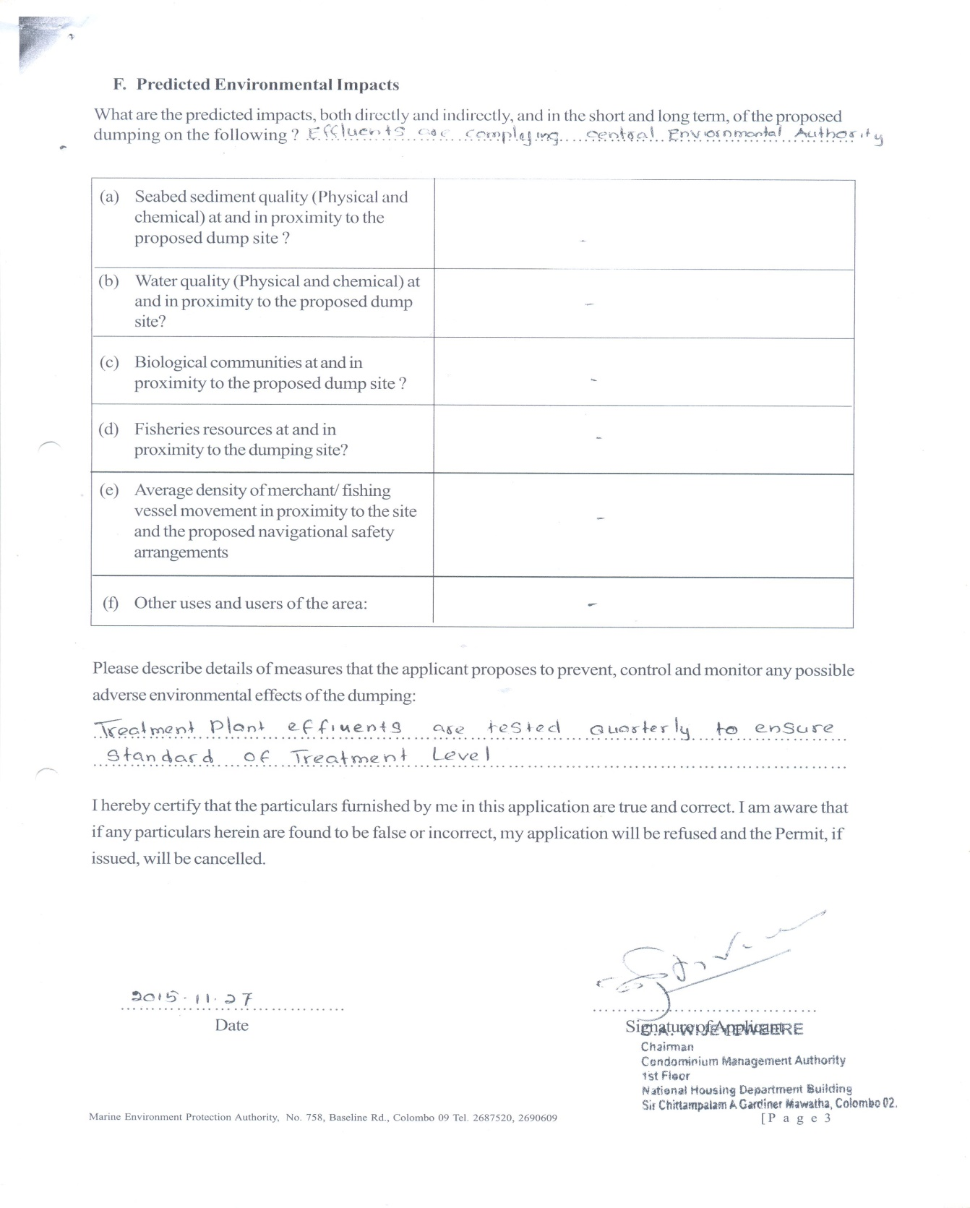

Annex 5- Lunawa housing scheme and disposal system
