Global Partnership on Output Based Aid Project
Sub – Project Environmental Assessment Report – No 05
Simplified and Conventional Extensions Stage-I
PD/GPOBA/SCE/2013/08

GPOBA Project
National Water Supply and Drainage Board
Sri Lanka
November 2013
1.0 Project Description
This sub project is organized under two categories, distinguishing “Connections to Conventional sewer extensions (1b)” from “Connections to simplified sewer extensions (1c1)”. Extensions with conventional sewer technology and connections for households located more than 20m from the main sewerage network are comes under “1b” and Extensions with simplified sewer (Shallow sewer) and connections for households located more than 20m from the main sewerage network comes under “1c1”.
Construction of Interceptor Manhole, connection to Y branch or manhole laying of new gravity sewer and connecting of grey and black water of household through catch pits to the interceptor shall be done under the both of above categories.
Under this sub project targeted to increase the household access in Dehiwala/Mt.Lavinia, Kolonnawa ,Ja-Ela/ekala and Moratuwa/Ratmalana area by providing sewerage connections to poor community who are living more than 20m away from existing sewerage network. Beneficiaries are selecting by limiting the monthly income and area of the lands. Though the communication campaign activities such as awareness programs, meetings, leaflet distribution etc will be done to make the community aware about this project and increase the beneficiaries under this project.
Area | Number of connections expected(1b) | Number of connections expected(1c1) | Maximum Monthly income Limit(Rs.) | Maximum Area of the Land (Perches)
Dehiwala/ Mt. Lavinia | 142 | 469 | 30,000.00 | 20
Kolonnawa | 125 | 262 | 20,000.00 | 10
Moratuwa/Ratmalana | 40 | 178 | 30,000.00 | 20
Ja- Ela /Ekala | 59 | - | 20,000.00 | 10
Total | 366 | 909

2.0 Required approvals and permits
- Approval from relevant road authorities and for all extensions
Requests for approvals have been submitted to the following authorities,(Annexure 1- Approval Request Letters)
- Dehiwala Municipal Council
- Moratuwa Municipal Council
- Kolonnawa Urban Council.
- Ja-ela Prdeshiya Saba
- Provincial Road Development Authority-western province
- Road Development Authority-(Colombo and Gampaha)

3.0 Existing Environmental Condition in project area
3.1 Geology
The general topography of the project implementing area consists of largely flat low lying terrain. Elevations vary only from 0m MSL to m 6 MSL. The geology of the area mainly falls in to Highland series Lithotectonic group
3.2 Stratigraphy and sub soil condition
. The geology of the area mainly falls in to Highland series Lithotectonic group, consisting of charnockitic (hyphesthene) gneiss, charnoliticbiotite gneiss and magmatic in parts.
The geological features above relate to global types and in the local areas of the project where pipe lines, Interceptor manhole and catch pits are positioning, the local geological features types could be vary.
The main global soil types of the area are regosols on recent beach sands in flat terrain in the coastal belt, Latosols and regosols on old red and yellow sands of flat terrain in the adjacent land strip to the coastal belt. Bog and half bog soils in and around water bodies such as bolgoda Lake system.
3.3 Rainfall characteristics and monthly average rainfall
Rainfall in the area is peaks in May to October. The general rainfall is monsoonal, conventional and digressional origin. The average annual rainfall for the project area is around 2000 – 3000 mm. Daily rainfall is measured at the principal meteorological station Ratmalana maintained by the Department of Meteorology.

As the ground water table is close to the ground level surface runoff is high.
Monthly Runoff for Moratuwa/ Ratmalana area is as follows.

Month | Jan | Feb | March | April | May | June | July | Aug | Sep | Oct | Nov | Dec
Runoff (mm) | 49 | 54 | 99 | 173 | 252 | 139 | 93 | 98 | 178 | 260 | 220 | 124

3.4 Wind Speed and Direction
Average wind speed is in the range of 7-10km/hr according to the data recorded at the Colombo meteorological station.
Month | Wind Speed (km/hr) | Dominant Direction
January | 9 | North East
April | 7 | South West
July | 10 | South West
October | 8 | South West

3.5 Temperature
Average annual temperature is in the area is in the range of 25-27.5 ⁰C
3.6 Relative Humidity
Relative humidity data are available for Ratmalana meteorological station, which is in the project area. Relative humidity is from 66% to 75% during the daytime, and it varies from 84% to 90% during the nighttime.
3.7 Hydrology
Surface drain pattern
The surface drain pattern of the Ratmalana/Moratuwa, Dehiwala/Mt. Lavinia areas is largely determined by Bolgoda Lake, Lunawa Lagoon and sea. The drainage in Dehiwala, Ratmalana North and Mt. Lavinia area is directed to sea through various road side drains. Ratmalana south and Moratuwa area western side of the Galle road surface water drains to Lunawa lagoon and eastern side of the Galle road area surface water mainly drains to Bolgoda lake.
Surface water of the Kolonnawa area mainly drains to Kelani Ganga and Dematagoda ela through the road side drains.
Surface water availability & uses
Surface water is available in the project area in large water bodies such as bolgoda Lake, Lunawa Lagoon, Kelani Ganga, Dematagoda ela etc. Water in lunawa lagoon is highly polluted and water in weras ganga also subjected to degrade. The Quality of Water available in the Dematagoda ela also highly polluted by industrial and domestic waste. There is no surface water source close to the site, which stores portable water.
Height of Ground water table
Water table is high in project area as it is close to the sea and low lying area. Ground water is contaminated by domestic and industrial wastewater as the industrial and domestic waste water is discharging to the existing water bodies and infiltration to the ground from the overflow of septic tanks.
Groundwater Uses
The quality of Groundwater is degraded in the area because of the domestic and industrial wastewater contaminated with the groundwater. Further to that groundwater is salty I the coastal belt. Hence there is hardly any use of groundwater in the project area.
Marine Outfalls
The shoreline within the proposed project area is a bare sandy beach with beach vegetation. Human settlements and carpentry shops can be seen along the beach and domestic sewerage and other waste have ruined the scenic value of the beach. Visual pollutants are scattered in the beach and in the surface water of the near shore area.
3.8 Water quality
NWSDB have established a water quality monitoring programme with sampling points have been identified in Moratuwa, Kolonnawa, Dehiwala and Jela Area to Monitor water quality of existing water bodies.
Possible Environmental Impacts
- Dust can be generated during the construction period.
- Disturbance to the road traffic
EMMP including preventing, Monitoring, Mitigation measures and identification of responsible parties
 | Key Impacts | Mitigation Measures | Monitoring actions | Responsible parties
1 | Dust generation during the construction period | Dust control measures such as spaying water in the dry seasons during construction period | Monitoring during site inspection and feedback from the community around the area | NWSDB and Contractor
2 | Disturbance to road traffic | Traffic control during construction and sign boards | Monitoring during site inspection | NWSDB and Contractor

Modes of Public Consultation and Disclosure
Public consultation and awareness programmes were conducted with the participation of GN and society leaders. Further to that distribution of leaflets among the beneficiaries by educating them about the project.

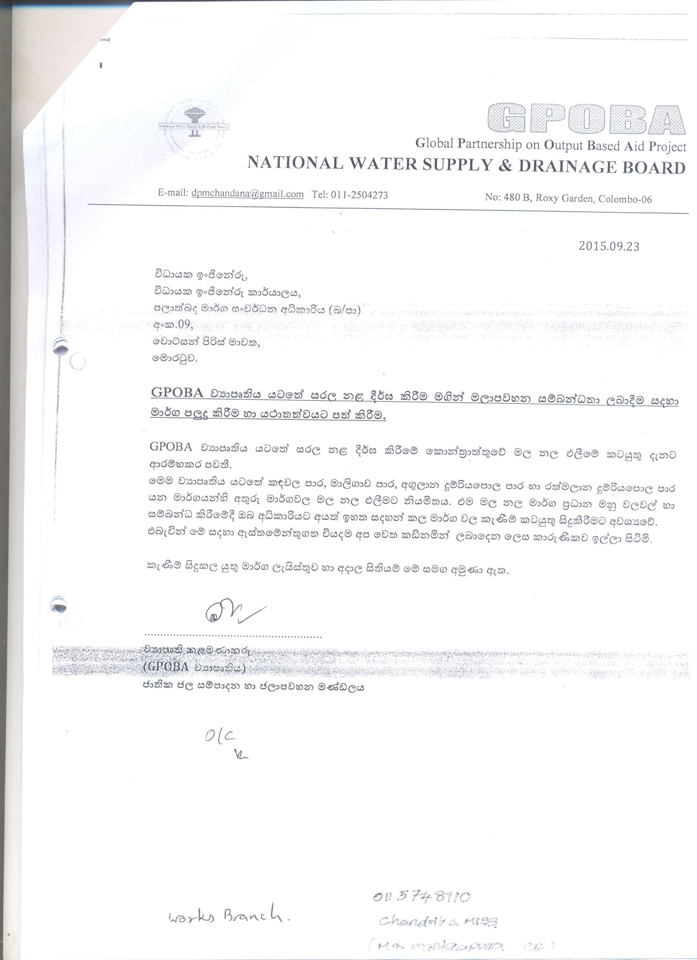
Annex - 1
