Global Partnership on Output Base Aid Project
Sub – Project Environmental Assessment Report – NO 04
Rehabilitation of Sewerage Treatment Plant at Tsunami Housing Scheme - Ratmalana

GPOBA Project
National Water Supply and Drainage Board
Sri Lanka
1.0 Project Description
The Tsunami scheme is situated near Ratmalana Economic Centre which is 500m away from Galle road (Golumadama Junction) in the Ratmalana divisional secretary area of the southern part of the Colombo city. This housing scheme consists of 328 housing units.
These people are severely suffering from lack of sanitation facilities as they are not having proper waste water disposal system. Existing septic tanks are frequently overflowing through open drains to nearby canal. Most of existing lines have been blocked and some of the sewers have been damaged. Existing anaerobic filters, pumping station and wetland have been abandoned and some part of structures has been damaged. Disinfection system also damaged and parts have been removed away by thieves due to poor security. Many complain have been received to Municipal councils from nearby people regarding overflowing of raw wastewater to existing canal.
1.1 Proposed system
It was proposed to do following rehabilitation work and management program as follows,
- Cleaning and replacing of damaged pipes
- Cleaning of septic tanks
- Cleaning and repair works for anaerobic filters
- Cleaning, planting of crops and repair works for wetlands
- Supply and installation of pumps, panel boards and rehabilitation of wet well
- Installation of chlorination system
- Repairs for boundary wall and gate
- Construction of watchers hut
- Provision of security through Dehiwala Municipal Council
- Construction of Interceptor manholes
- Operation and maintenance to be done by NWSDB
Wastewater treatment process,

2.0 Required approvals and permits
- Environmental clearance from the Central Environmental Authority (CEA)
- Construction Approval from Dehiwala Municipal Council
- Consent letter from Divisional secretariat, Ratmalana
All approvals which have taken are attached in the annexure 1-3
3.0 Existing Environmental Condition in project area
3.1 Geology
The general topography of the Tsunami Housing scheme land consists of largely flat low lying terrain.
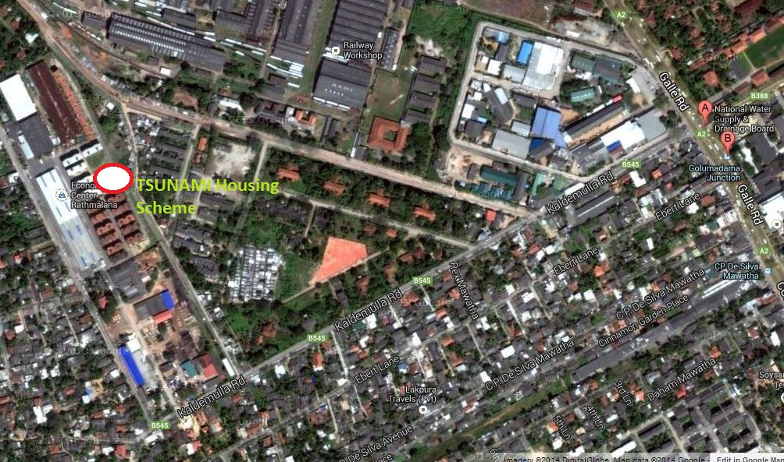
3.2 Stratigraphy and sub soil condition
Top most top layer is consisting of filled gravel layer and then loose sand layer. Due to the sandy sub soil layers permeability of sub soil is higher.
3.3 Rainfall characteristics and monthly average rainfall
Rainfall in the area is peaks in May to October. The general rainfall is monsoonal, conventional and digressional origin. The average annual rainfall for the project area is around 2000 – 3000 mm. Daily rainfall is measured at the principal meteorological station Ratmalana maintained by the Department of Meteorology.

As the ground water table is close to the ground level surface runoff is high.
Monthly Runoff for Moratuwa/ Ratmalana area is as follows.
Month | Jan | Feb | March | April | May | June | July | Aug | Sep | Oct | Nov | Dec
Runoff (mm) | 49 | 54 | 99 | 173 | 252 | 139 | 93 | 98 | 178 | 260 | 220 | 124

3.4 Wind Speed and Direction
Average wind speed is in the range of 7-10km/hr according to the data recorded at the Colombo meteorological station.
Month | Wind Speed (km/hr) | Dominant Direction
January | 9 | North East
April | 7 | South West
July | 10 | South West
October | 8 | South West

3.5 Temperature
Average annual temperature is in the area is in the range of 25-27.5 ⁰C
3.6 Relative Humidity
Relative humidity data are available for Ratmalana meteorological station, which is in the project area. Relative humidity is from 66% to 75% during the daytime, and it varies from 84% to 90% during the nighttime.
3.7 Hydrology
Surface drain pattern
Surface drain system of Ratmalana Tsunami housing scheme draining to small canal which is directed to Lunawa lagoon.
Surface water availability & uses
Close to the site there some small canal which are draining surface runoff and domestic wastewater (Grey water) to the large canal which is directed to Lunawa lagoon. There is a canal which carries surface runoff and wastewater close to the proposed site. It is highly polluted. There is no surface water source close to the site, which stores portable water.

Height of Ground water table
Water table is ranging from 2-3m from ground level. Ground water is contaminated by domestic wastewater due to partial treatment of domestic waste water in septic tanks and untreated wastewater by overflowed septic tanks and toilets.
Groundwater Uses
The quality of Groundwater is degraded in the area because of the domestic wastewater contaminated with the groundwater. Further to that groundwater is salty as the site is located close to the sea. Hence there is hardly any use of groundwater in the project area.
Marine Outfalls
Marine outfall which is close to project area is from Lunawa lagoon and it is 1.5km away from proposed project area.
3.8 Water quality
NWSDB have established a water quality monitoring programme with sampling point located closer to the site (Annex . Samples will be taken quarterly basis.
Water quality testing for the first quarter of the year 2014 was done and results as follows.
 | Parameter | Value
1 | BOD₅ | 225 mg/l
2 | DO | Nil
3 | E-coli5 | 1 x 10⁵
4 | Total fecal coliforms | 2.24 x 10⁵

Possible Environmental Impacts
- As we are discharging treated water in to existing canal water quality parameters of the existing canal can be changed (Reduced)
- Dust can be generated during the construction period.
- Possibility of odor from the anaerobic filters, discharge points and Pumping station

EMMP including preventing, Monitoring, Mitigation measures and identification of responsible parties
 | Key Impacts | Mitigation Measures | Monitoring actions | Responsible parties
1 | Water quality of existing Water canals | At the design stages follow up the standards relevant inland waters the canal is directed to sea and better operation and maintenance of the DEWAT system | Existing water quality testing prior to the project and post quality testing and quality testing for effluent from the treatment system quarterly. | NWSDB
3 | Dust generation during the construction period | Dust control measures such as spaying water in the dry seasons during construction period | Monitoring during site inspection and feedback from the community around the area | NWSDB and Contractor
4 | Possibility of odor from filters, Pumping stations and discharge points | Better operation and maintenance of the DEWAT system, O&M shall be done by NWSDB. Discharge the effluent through a seal Manhole |  | NWSDB

Modes of Public Consultation and Disclosure
Public consultation and awareness programmes were conducted with the participation of Honorable Deputy Mayer and Municipal council members and GS. There were no any objections from the community in the Lunawa Housing scheme. But some people were opposed to beneficiary contribution. Project team is planning to do mobile service and awareness program to collect beneficiary contribution from households.

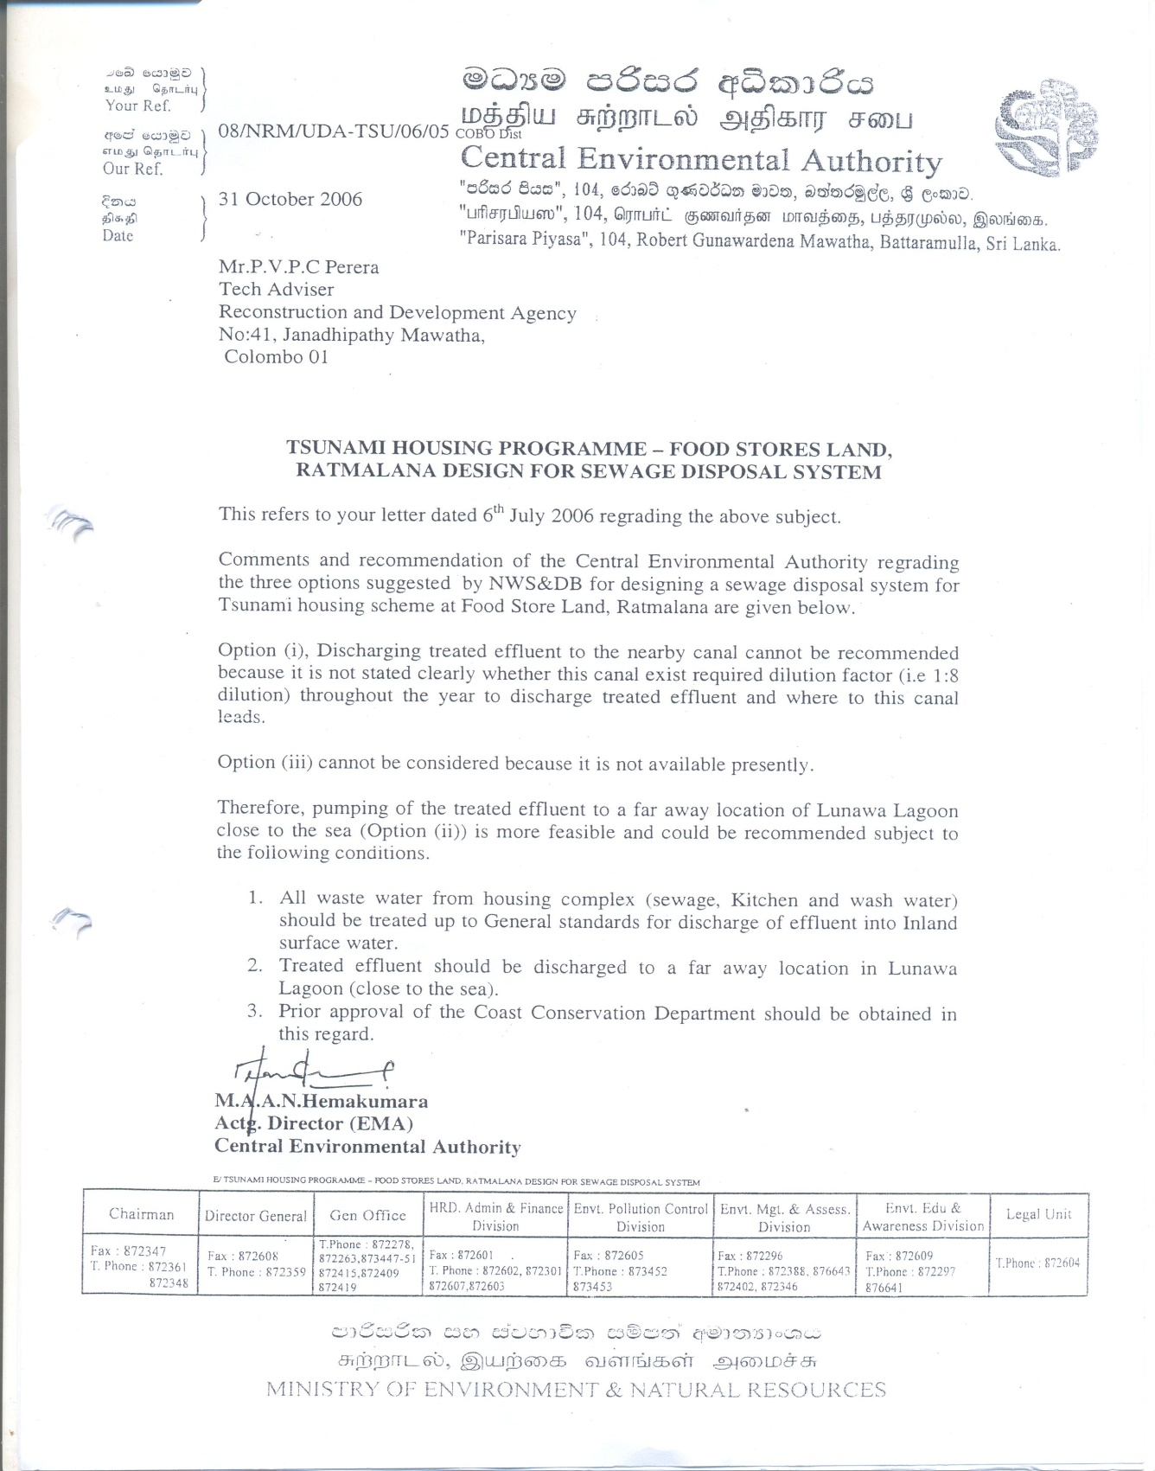
Annex - 01

Annex - 2
